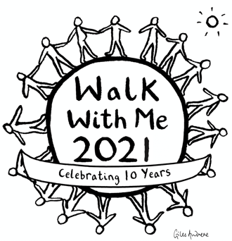

We have consulted a Covid-safe risk assessment and aim to apply as many of the advised protocols as possible.

Firstly, if necessary, we will cap the number of participants in order to better and more easily implement social distancing. We are very much hoping to avoid this by using the following measures.

We will be taking temperatures as participants arrive at the start line and going through a brief Covid questionnaire, including checking contact numbers in line with track and trace measures.

We would usually start in the Moulsford School Sports Hall for a warm up and safety briefing. In 2021 we will not be using the Sports Hall at all and all registration, warm up and briefings will take place outside on the top field above the river (where the finish line is usually located). This will allow for any necessary social distancing.

Moulsford School continues to operate during lockdown and so they already have in place a number of marquees to accommodate their pupils 'outside'. We have been given permission to use these. In addition, they have outside hand sanitising stations which we are also allowed to use. They have given us access to two loos in the theatre block which is adjacent to the driveway. We will be controlling access to these using an outside queuing system.

We may stagger the start, giving small groups of people specific start times at 3-5 minutes intervals. This will avoid a large group setting off through Moulsford Village at the same time.

Once walkers have set off, we will be asking you all to manage your own social distancing. We have a new route this year and this should be possible along its entirety, as there are very few narrow footpaths to negotiate.

Any food or drink we offer must be in sealed packaging. Therefore, at our checkpoints and water stations, we will have bottled water. We were hoping to move away from using bottles this year, but that will have to wait until 2022. Any food items, e.g. flapjacks, will be individually wrapped. We will be finalising the details on how we will further manage our checkpoints over the coming weeks.

At the finish line we very sadly will not be offering a BBQ or bar. We will not be encouraging our walkers or their supporters to 'hang around' but hopefully will still be able to create a fun and celebratory atmosphere as you cross the finish line. Again, any refreshments available will be individually packaged.

We are continually updating our protocols. Please be reassured that we are taking this situation very seriously and that the safety of our walkers and team is our main priority - as it always has been.

The WalkWithMe Team
www.walkwithmeuk.org
walk_with_me@yahoo.com

